Finances for Common Families
This site will provide basic financial concepts so common people (with little financial knowledge) can learn the importance of using a budget and how to create a basic one to keep track of their monthly expenses. It will also introduce them to interest and compound interest, showing them how it can work for their favor or against them.

Basic Financial Concepts

Budget
According to the AI Gemini, in simple terms, a budget is a financial plan for a specific period, like a month or a year, that tracks a person’s income and expenses. It serves as a roadmap to guide a person's spendings and help him/her meet specific financial goals, like increasing savings or reducing debt. It is a tool that, if the person or family uses it with discipline, could help them to ensure that they do not spend more than they earn. In this website we will learn how to create a monthly income.

Income
For this purpose, income is the money that an individual receives in exchange for labor or provided service. When used for creating a budget, it will be considered for the same period that the budget will include.

Expenditure
We will define it as the money spent on something, such taxes, donations, and other spendings like food, clothing, services, etc. In this case, we will consider all the spendings made for a person or family within a month period. We can classify our expenditures as fixed or variable.

Fixed Expenditures
It is a cost that remains the same from a period to the next, making it predictable and stable; for example: Rent or mortgage, car payments, insurances, subscriptions or memberships, taxes, tuition, services (internet, cell phone), and current debts (loan payments).

Variable Expenditures
They are those that change in cost and occurrence, so can be difficult to plan for as they may vary, such as unforeseen events or discretionary spending. For example: Groceries, gas, entertainment, medical care, clothing, personal care, eating out, hobbies, and utilities (electricity, water, gas, etc.).

Financial Interest
A "financial interest" is any stake or potential monetary gain an individual, their family, or a business has in a financial asset, transaction, or enterprise. Put in simple terms, is the extra money you pay to banks for using their money, like when you buy with a credit card and you do not pay the whole amount after a monthly period, or when you get a loan to buy something at the moment and then you keep paying for a period of time.

Compound Interest
Compound interest is the interest earned on both the initial principal amount and on the accumulated interest from previous periods. It's often described as earning "interest on interest" and causes your savings or investment to grow at an accelerating rate over time, like a snowball effect. Unfortunately, since not all of us understand it, this is also the way we make rich people richer as we become poor and poor.

Paying Interest
Now that we have a notion about interest, let’s see how it is used by the financial system.
Every time we use credit for paying, we will pay interest to the financial entity that provided the credit. In the following example, we will see how interest makes us pay more than we expect to when buying a car.
Let’s suppose we want to buy a fifty thousand dollars car (Its brand and whether if it is new or used or no is out of the scope of this example). We do not have any money now, but we want it today, so we buy it by credit, with an annual interest rate of 15%, for a period of 6 years, which divides into a monthly payment of approximately $1,057.
From the example we learn that:
- At the end of the 72 months (6 years) the owner of the car would have paid $76, 122
- The extra payment is more than $26, 122 more than the cost of the car due to the interest.
(The example does not include insurance and other costs that financial entities charge their customers with)

Earning Interest
Now, let’s learn how to use interest, specifically compound interest, to our favor.
The following example illustrates how we can make better financial decisions if, instead of buying our goods now with the use of credit, we have the discipline and wait and save for a while. We will use a similar monthly payment to the one used in our credit paying example, but this time rounding the monthly payment to $1,000 for the same 72-month period. Since the banks do not pay the same interest to their customers as the one that they request from them, we will use a 5% interest rate.

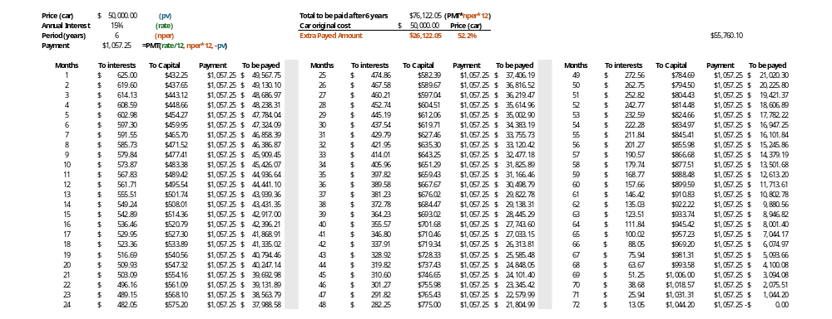

From the example we conclude that:
- A person who saves $1,000 a month can have enough money to buy the same car within less than 4 years.
- If this person continues to save the same amount of money, will still be able to save the extra amount of about $29,638 by the end of the 72-month period.
- By saving instead of using credit for financing the bought of the car, the person has saved more than $55,760 when considering his/her savings after the 72 months and the extra money that was not paid due to the interests, which is enough to buy another car of a similar price.

